SIMATS ENGINEERING
SAVEETHA INSTITUTE OF MEDICAL AND TECHNICAL SCIENCES
COMPUTER SCIENCE AND ENGINEERING PROGRAMME
CSA1302 - THEORY OF COMPUTATION

LAB EXPERIMENT - 2

Name: J . Anisha Jenifer
Reg No: 192511004

QUESTION
1. Write a C program to simulate a Non-Deterministic Finite Automata (NFA)
for the given language representing strings that start with o and end with 1.

AIM
To write and execute a C program to simulate a Non-Deterministic Finite Automaton (NFA) that accepts binary strings starting with 0 and ending with 1.

ALGORITHM
- Start the program.
- Read a binary string containing only 0 and 1.
- Check whether the input contains only valid binary symbols.
- Check whether the first symbol is 0. If not, reject the string.
- Simulate the NFA by maintaining the possible current states.
- For each input symbol, update the possible states according to the transition rules.
- After processing the entire string, check whether any possible state is an accepting state.
- If an accepting state is reached, print String Accepted; otherwise, print String Rejected.
- Stop the program.

3. PROGRAM

#include <stdio.h>

#include <string.h>

int main() {

char str[100];

int i, len;

int state0 = 1, state1 = 0;

int next0, next1;

printf("Enter a binary string: ");

scanf("%99s", str);

len = strlen(str);

for (i = 0; i < len; i++) {

if (str[i] != '0' && str[i] != '1') {

printf("Invalid input\n");

return 0;

}

}

if (len < 2 || str[0] != '0') {

printf("String Rejected\n");

return 0;

}

for (i = 1; i < len; i++) {

next0 = 0;

next1 = 0;

if (state0) {

if (str[i] == '0') {

next0 = 1;

} else {

next0 = 1;

next1 = 1;

}

}

state0 = next0;

state1 = next1;

}

if (state1)

printf("String Accepted\n");

else

printf("String Rejected\n");

return 0;

}

4. OUTPUT
The program was executed with the input string "abba".
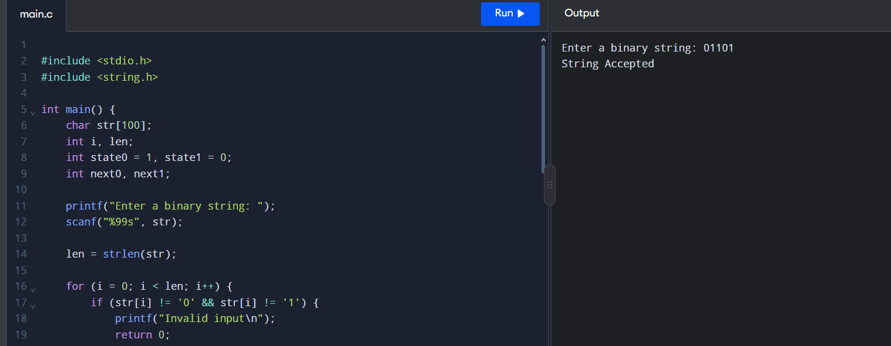
Output screenshot: Input = 01101; binary String Accepted.

5. RESULT
Thus, the C program to simulate an NFA that accepts binary strings starting with 0 and ending with 1 was written and executed successfully.
Note: I have interpreted the letter o in your question as the digit 0, assuming the intended alphabet is binary {0, 1}.

